MySQL ROLLUP

Here, you will learn how to use the MySQL ROLLUP clause to generate subtotals and grand totals.

## **Setting up a sample table**

The following statement creates a new table named sales that stores the order values summarized by product lines and years. The data comes from the products, orders, and orderDetails tables in the sample database.

CREATE TABLE sales

SELECT

productLine,

YEAR(orderDate) orderYear,

SUM(quantityOrdered * priceEach) orderValue

FROM

orderDetails

INNER JOIN

orders USING (orderNumber)

INNER JOIN

products USING (productCode)

GROUP BY

productLine ,

YEAR(orderDate);

The following query returns all rows from the sales table:

SELECT * FROM sales;

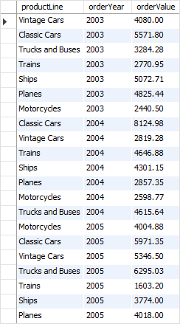

## **MySQL ROLLUP Overview**

A grouping set is a set of columns to which you want to group. For example, the following query creates a grouping set denoted by (productline)

SELECT

productline,

SUM(orderValue) totalOrderValue

FROM

sales

GROUP BY

productline;

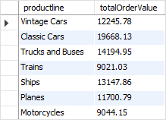

The following query creates an empty grouping set denoted by the ():

SELECT

SUM(orderValue) totalOrderValue

FROM

sales;

MySQL ROLLUP - Empty Grouping Set

If you want to generate two or more grouping sets together in one query, you may use the [UNION ALL](https://www.mysqltutorial.org/sql-union-mysql.aspx) operator as follows:

SELECT

productline,

SUM(orderValue) totalOrderValue

FROM

sales

GROUP BY

productline

UNION ALL

SELECT

NULL,

SUM(orderValue) totalOrderValue

FROM

sales;

Here’s the query output:

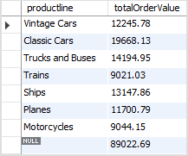

Because the UNION ALL requires all queries to have the same number of columns, we added NULL in the select list of the second query to fulfill this requirement.

The NULL in the productLine column identifies the grand total super-aggregate line.

This query is able to generate the total order values by product lines and also the grand total row. However, it has two problems:

1. The query is quite lengthy.
2. The performance of the query may not be good since the database engine has to internally execute two separate queries and combine the result sets into one.

To fix these issues, you can use the ROLLUP clause.

The ROLLUP clause is an extension of the GROUP BY clause with the following syntax:

SELECT

select_list

FROM

table_name

GROUP BY

c1, c2, c3 WITH ROLLUP;

The ROLLUP generates multiple grouping sets based on the columns or expressions specified in the GROUP BY clause. For example:

SELECT

productLine,

SUM(orderValue) totalOrderValue

FROM

sales

GROUP BY

productline WITH ROLLUP;

Here is the output:

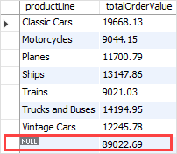

As clearly shown in the output, the ROLLUP clause generates not only the subtotals but also the grand total of the order values.

If you have more than one column specified in the GROUP BY clause, the ROLLUP clause assumes a hierarchy among the input columns.

For example:

GROUP BY c1, c2, c3 WITH ROLLUP

The ROLLUP assumes that there is the following hierarchy:

c1 > c2 > c3

And it generates the following grouping sets:

(c1, c2, c3)

(c1, c2)

(c1)

()

And in case you have two columns specified in the GROUP BY clause:

GROUP BY c1, c2 WITH ROLLUP

then the ROLLUP generates the following grouping sets:

(c1, c2)

(c1)

()

See the following query example:

SELECT

productLine,

orderYear,

SUM(orderValue) totalOrderValue

FROM

sales

GROUP BY

productline,

orderYear

WITH ROLLUP;

Here is the output:

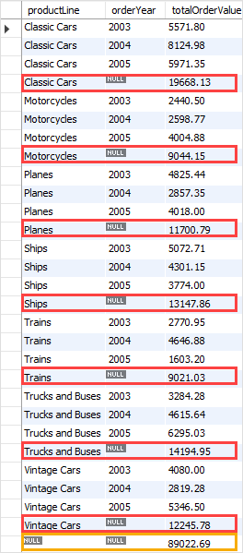

The ROLLUP generates the subtotal row every time the product line changes and the grand total at the end of the result.

The hierarchy in this case is:

productLine > orderYear

If you reverse the hierarchy, for example:

SELECT

orderYear,

productLine,

SUM(orderValue) totalOrderValue

FROM

sales

GROUP BY

orderYear,

productline

WITH ROLLUP;

The following picture shows the output:

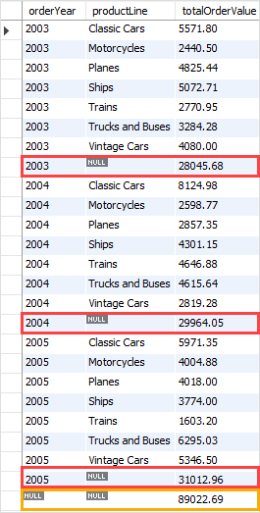

The ROLLUP generates the subtotal every time the year changes and the grand total at the end of the result set.

The hierarchy in this example is:

orderYear > productLine

## **The GROUPING() function**

To check whether NULL in the result set represents the subtotals or grand totals, you use the GROUPING() function.

The GROUPING() function returns 1 when NULL occurs in a supper-aggregate row, otherwise, it returns 0.

The GROUPING() function can be used in the select list, HAVING clause, and (as of MySQL 8.0.12 ) ORDER BY clause.

Consider the following query:

SELECT

orderYear,

productLine,

SUM(orderValue) totalOrderValue,

GROUPING(orderYear),

GROUPING(productLine)

FROM

sales

GROUP BY

orderYear,

productline

WITH ROLLUP;

The following picture shows the output:

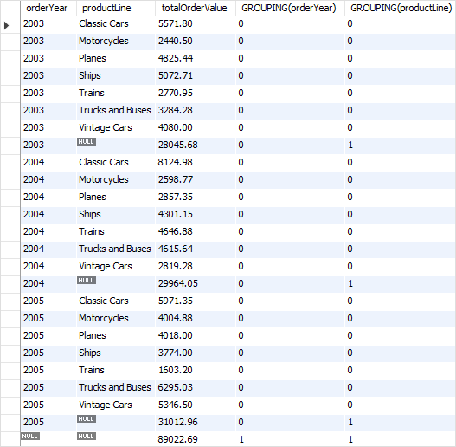

The GROUPING(orderYear) returns 1 when NULL in the orderYear column occurs in a super-aggregate row, 0 otherwise.

Similarly, the GROUPING(productLine) returns 1 when NULL in the productLine column occurs in a super-aggregate row, 0 otherwise.

We often use GROUPING() function to substitute meaningful labels for super-aggregate NULL values instead of displaying it directly.

The following example shows how to combine the [IF()](https://www.mysqltutorial.org/mysql-if-function.aspx) function with the GROUPING() function to substitute labels for the super-aggregate NULL values in orderYear and productLine columns:

SELECT

IF(GROUPING(orderYear),

'All Years',

orderYear) orderYear,

IF(GROUPING(productLine),

'All Product Lines',

productLine) productLine,

SUM(orderValue) totalOrderValue

FROM

sales

GROUP BY

orderYear ,

productline

WITH ROLLUP;

The output is:

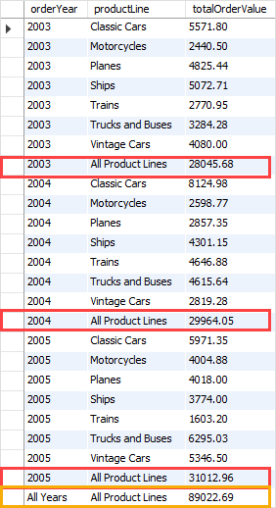

Here, you have learned how to use the MySQL ROLLUP() to generate multiple grouping sets considering a hierarchy between columns specified in the GROUP BY clause.